MINUTES FOR DISTRICT 41 MEETING MARCH 17, 2022 (HYBRID)
NOTE: Mailing Address - District 41 Treas. P.O. Box 7226, Villa Park, IL 60181
NOTE: District 41 web site: dupage41aa@gmail.com
NOTE: Mailing Address - District 41 Answering Service, P.O. Box 6365, Villa Park, IL 60181-5318
NOTE: NIA web site: www.aa-nia.org

PRESENT AT MEETING:
Maggie A., Jeffery A., Lora B., Mark F., Lee K., Lael L., Leroy L., Brian L., Jeane M., Debbie Ma., Tom Ma., Susan M., Tom Mo., Sarah O., Lydia S. and Chris S.
Meeting opened at 7:00 p.m. with a Quiet Time, Serenity Prayer, GSR Preamble, 3rd Tradition and 3rd Concept for World Service.
Chris S. chaired the meeting.

INTRODUCTIONS:

New GSRs – None.

Visitors – Gene T.

Anniversaries – Maggie A. (10 yrs.), Lee K. (42 yrs.).

Birthdays – Leroy L. . . . [inaudible]

Announcements – None.

GSR-CC & Q: GSRs reported on their meetings.

OFFICERS REPORTS:
SECRETARY: (Tom Mo.) Minutes from February were put into the record.
TREASURER: (Lydia S.) Reviewed contributions and expenses. See Report below:
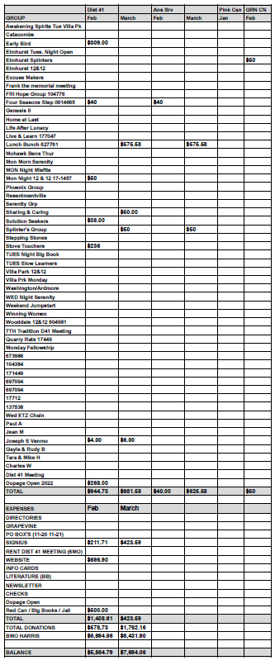
DCM: (Chris S.) Reviewed activities at Spring Assembly, which he and Jeffrey A. attended:
Pink Can Fund using Streamwood address only.
General Service Conference will be April 24-30.
Pre-General Service Conference Workshop will be held on April 9th. It will by a hybrid meeting.
The Area Accessibility Alternate Chair and Treatment Chair were filled.
State Conference will be held August 12-14.
Next year’s Spring Assembly will be March 10-12 at the Hyatt Schaumburg.
Area 20 voted to send $10,000 to General Service Office.
Big Book Conference will be October 20 at Parkview Community Church in Glen Ellyn.
ALT. DCM: (Jeff A.) Further reviewed Spring Assembly. Will be attending local meetings in an effort to find more GSRs.
ACCESSIBILITIES: (OPEN)
ANSWERING SERVICE: (Maggie A.). Service is doing well. Thanked everyone for their support.
ALT. ANSWERING SERVICE: (Open)
ARCHIVES: (Lael L.) No report.
BTG: (Susan M.) Attended Area Assembly. Met with Karen (Area BTG Chair) and C.J.
CPC: (Open)
ALT. CPC: (Open)
PI: (Open)
CORRECTIONS: (Brian L.) Pink Can checks should note it’s for District 41. Meetings going well in Jail. . . . [inaudible]
ALT. CORRECTIONS: (Gary C.) Absent.

GRAPEVINE: (Joan N.) Absent.
ALT. GRAPEVINE: (Open)
LITERATURE: (Ed R.) Absent.
ALT. LITERATURE: (Open)
LCM: (Leroy L.) No report.
NEWSLETTER: (Open)
TREATMENT: (Tom Ma.) No report. Will meet with Susan M.
ALT. TREATMENT: (Open)
WEBTECH: (Jeane M.) Reported 1,776 views in February. Focusing on District 41 meeting changes. Made several contacts in search of meeting information. Review PDF list posted on District 41 website. Emphasized need for meeting numbers from GSO. Asked for information on events and conferences.
WORKSHOPS: (Open)
OLD BUSINESS: Tabled discussion of DuPage Open.
Talked about potential speakers for Ignatia House Sunday Night Speaker Meeting.
ONGOING BUSINESS: Discussion of hard copy Directories was tabled.
NEW BUSINESS: Lora B. will have more complete information on NIA Big Book Conference next month.
Closed with Responsibility Statement.

If you are a District 41 member and have not attended a district meeting within the last three months, chances are your name will be removed from the mailing list.

The next meeting will be held Thursday, April 21, 2022 @ 7:00 P.M.

