MINUTES FOR DISTRICT 41 MEETING APRIL 21, 2022 (HYBRID)
NOTE: Mailing Address - District 41 Treas. P.O. Box 7226, Villa Park, IL 60181
NOTE: District 41 web site: dupage41aa@gmail.com
NOTE: Mailing Address - District 41 Answering Service, P.O. Box 6365, Villa Park, IL 60181-5318
NOTE: NIA web site: www.aa-nia.org

PRESENT AT MEETING:
Maggie A., Jeffery A., Lora B., Mark F., Susan H., Lee K., Lael L., Leroy L., Brian L., Jeane M., Debbie Ma., Tom Ma., Susan M., Tom Mo., Joan N., Sarah O., Ed. R., Lydia S. and Chris S.
Meeting opened at 7:00 p.m. with a Quiet Time, Serenity Prayer, GSR Preamble, 4th Tradition and 4th Concept for World Service.
Chris S. chaired the meeting.

INTRODUCTIONS:

New GSRs – Steve G. and John T.

Visitors – Eugene T. and Andre G.

Anniversaries – None.

Birthdays – Ed R. and Chris S.

Announcements – None.

GSR-CC & Q: GSRs reported on their meetings.

OFFICERS REPORTS:
SECRETARY: (Tom Mo.) Minutes from March were put into the record.
TREASURER: (Lydia S.) Reviewed contributions and expenses. See Report below:
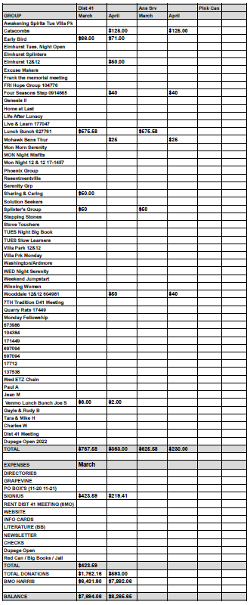
DCM: (Chris S.) No report.
ALT. DCM: (Jeff A.) Will make sure to communicate with DCM to make sure District 41 is represented at future Area functions.
ACCESSIBILITIES: (OPEN) Susan H. (Area Chair) will be Chair for Big Book Conference on October 29th, working on translators in Spanish (ASL).
ANSWERING SERVICE: (Maggie A.). Will redo list of phone volunteers and asked for new volunteers. Has many directories from January 2020. Recommended Everything AA app.
ALT. ANSWERING SERVICE: (Open)
ARCHIVES: (Lael L.) No report.
BTG: (Susan M.) No report.
CPC: (Open)
ALT. CPC: (Open)
PI: (Open)
CORRECTIONS: (Brian L.) Will attend planning meeting next week for National Corrections Conference this November in Schaumburg. Also brought flyers in Spanish and English. Meetings in the Jail are doing well. Will have Pink Can report next month.
ALT. CORRECTIONS: (Gary C.) Absent.

GRAPEVINE: (Joan N.) No report.
ALT. GRAPEVINE: (Open)
LITERATURE: (Ed R.) Reported that GSO is looking for individual stories for the 5th edition of the Big Book. Stated that Brian L. brought pamphlets to the Addison Library. Ed R. call Bensonville and Wood Dale Libraries concerning possible literature deliveries. Received no response. Will order more literature. Still has beginner kits for $1 each.
ALT. LITERATURE: (Open)
LCM: (Leroy L.) Will compare Meeting Guide to Area directories to see who the current GSRs are.
NEWSLETTER: (Open)
TREATMENT: (Tom Ma.) Reached out to Good Samaritan Hospital. Will have more next month. Will talk to SHARE. Steve G. explained the setup at the Lindon Oaks detox unit.
ALT. TREATMENT: (Open)
WEBTECH: (Jeane M.) Reported 2,100 visits in March. Explained meeting classifications in the meeting schedule PDF posted on D-41 website. Schedule encompasses meetings in Districts 41 and 42.
WORKSHOPS: (Open)
OLD BUSINESS: Lora B. attended pre-GSO Conference. Stated that Chris (Area delegate) will report later.
ONGOING BUSINESS: GSRs have until May 4 to submit questions to Area delegate.
Chris S. announced that the Stove Touchers Group will be handling the speaker assignments for May at Ignatia House.
NEW BUSINESS: Agenda format discussion and GSR representation discussion were tabled until next month.
Lora B. volunteered for Alternate Corrections Chair and was voted in.
Leroy L. made it known that any workshop at Christ Church in Oakbrook, must be insured.
Motion to give Ed R. a $500 budget for Literature passed.
Discussion of prospective budgets for various chairs was tabled.
Closed with Responsibility Statement.

If you are a District 41 member and have not attended a district meeting within the last three months, chances are your name will be removed from the mailing list.

The next meeting will be held Thursday, May 19, 2022 @ 7:00 P.M.

