MINUTES FOR DISTRICT 41 MEETING MAY 19, 2022 (HYBRID)
NOTE: Mailing Address - District 41 Treas. P.O. Box 7226, Villa Park, IL 60181
NOTE: District 41 web site: dupage41aa@gmail.com
NOTE: Mailing Address - District 41 Answering Service, P.O. Box 6365, Villa Park, IL 60181-5318
NOTE: NIA web site: www.aa-nia.org

PRESENT AT MEETING:
Lora B., Mark F., Susan H., Lael L., Jeane M., Tom Mo., Joan N., Ed. R. and Chris S.
Meeting opened at 7:00 p.m. with a Quiet Time, Serenity Prayer, GSR Preamble, 5th Tradition and 5th Concept for World Service.
Chris S. chaired the meeting.

INTRODUCTIONS:

New GSRs – Chris (Wednesday Night Serenity Group)

Visitors – None.

Anniversaries – None.

Birthdays – None.

Announcements – None.

GSR-CC & Q: GSRs reported on their meetings.

OFFICERS REPORTS:
SECRETARY: (Tom Mo.) Minutes from April were put into the record.
TREASURER: (Lydia S.) Absent. No report.
DCM: (Chris S.) Will attend Area Meeting on June 11th.
ALT. DCM: (Jeff A.) Absent. No report.
ACCESSIBILITIES: (OPEN) Susan H. (Area Chair) attended Area Meeting last week. Stated that the Delegate report will be posted soon on Area website. Delegate will attend various District meetings and provide a brief report. A COVID occurred at the General Service Conference. Twenty-eight of 13 delegates were affected. Presented Accessibilities Checklist to be used by local meetings. Sue H. reviewed items on the list. Working on procuring a translator for the Big Book Conference. Susan H. also wrote an article for Concepts Newsletter that included the Checklist:
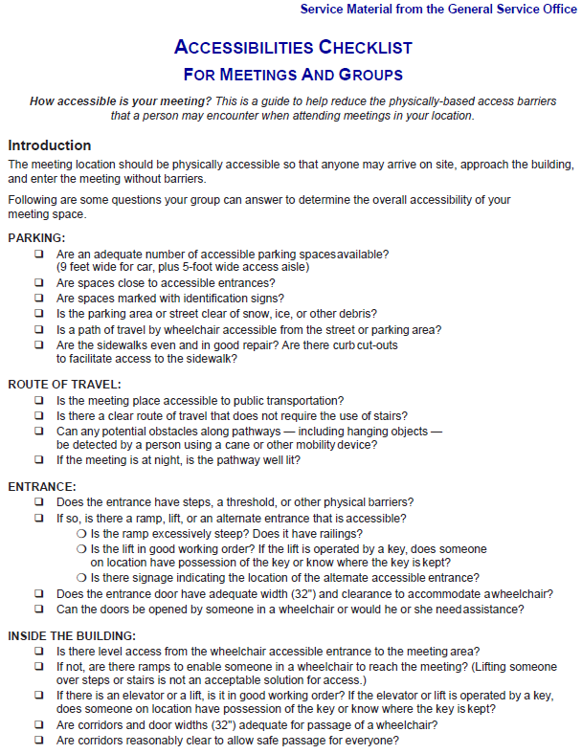
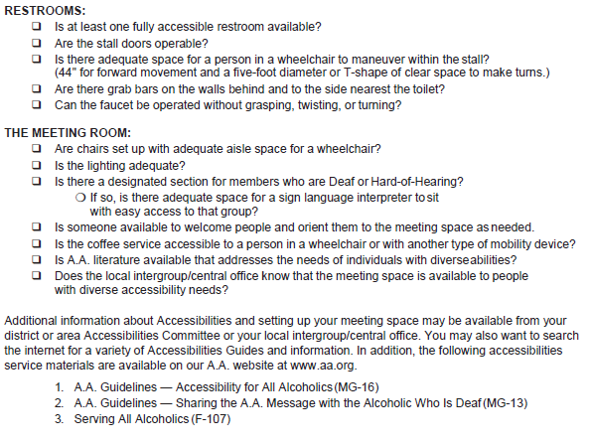
ANSWERING SERVICE: (Maggie A.). Absent. No report.
ALT. ANSWERING SERVICE: (Open)
ARCHIVES: (Lael L.) No report.
BTG: (Susan M.) Absent. No report.
CPC: (Open)
ALT. CPC: (Open)
PI: (Open)
CORRECTIONS: (Brian L.) Absent. No report.
ALT. CORRECTIONS: (Lora B.) Preparations for Corrections workshop on November 11-13 at Hyatt Regency in Schaumburg, are underway. Area Pink Can balance is $4,857.

GRAPEVINE: (Joan N.) Reported there was no Area Grapevine online meeting this month. Susan H. will send Grapevine info to Joan.
ALT. GRAPEVINE: (Open)
LITERATURE: (Ed R.) Submitted order for literature from GSO. Cost was $61.99. Will restock Lombard Library tomorrow.
ALT. LITERATURE: (Open)
LCM: (Leroy L.) Absent. No report.
NEWSLETTER: (Open)
TREATMENT: (Tom Ma.) Absent. No report.
ALT. TREATMENT: (Open)
WEBTECH: (Jeane M.) Reported 1,583 views in April. Posted a new meeting list PDF and mentioned that there is a translator available on the District website. Asked for information and events for posting.
WORKSHOPS: (Open)
OLD BUSINESS: Ideas for changes to the District Meeting Agenda were discussed. Considered ways to get more GSRs at local meetings. Discussion of budget for various Chairs was tabled.
ONGOING BUSINESS: Discussion of hard copy Directories was tabled.
Chris S. stated that he had made contact with a source who can provide information on treatment centers and schools that would like to be contacted by the District. More details to follow.
NEW BUSINESS: Motion to invite Delegate to August 18th District Meeting passed.
Lael L. will consider consuming Newsletter Chair position.
Closed with Responsibility Statement.

If you are a District 41 member and have not attended a district meeting within the last three months, chances are your name will be removed from the mailing list.

The next meeting will be held Thursday, June 16, 2022 @ 7:00 P.M.

