MINUTES FOR DISTRICT 41 MEETING JUNE 16, 2022 (HYBRID)
NOTE: Mailing Address - District 41 Treas. P.O. Box 7226, Villa Park, IL 60181
NOTE: District 41 web site: dupage41aa@gmail.com
NOTE: Mailing Address - District 41 Answering Service, P.O. Box 6365, Villa Park, IL 60181-5318
NOTE: NIA web site: www.aa-nia.org

PRESENT AT MEETING:
Jeffrey A., Lora B., Susan H., Lael L., Jeane M., Tom Ma., Tom Mo., Joan N., Ed R. and Lydia S.
Meeting opened at 7:00 p.m. with a Quiet Time, Serenity Prayer, GSR Preamble, 6th Tradition and 6th Concept for World Service.
Jeffrey A. chaired the meeting.

INTRODUCTIONS:

New GSRs – None.

Visitors – None.

Anniversaries – Lael L. (9 yrs.).

Birthdays – None.

Announcements – None.

GSR-CC & Q: None.

OFFICERS REPORTS:
SECRETARY: (Tom Mo.) Minutes from May were put into the record.
TREASURER: (Lydia S.) Reviewed donations and expenditures. Lydia S. reported that the check for $500 for Big Books at DuPage County Jail, was cashed. Treasurer’s Report was approved. Lydia S. presented prospective budget amounts for various committees.
Ending balance $8,049.12. See Report.
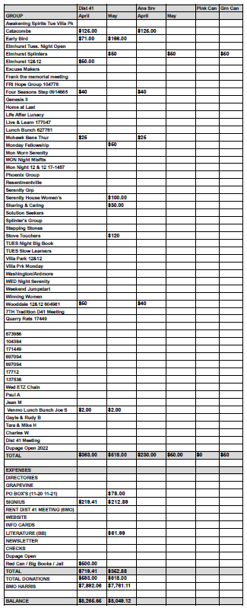

DCM: (Chris S.) Absent. No report.
ALT. DCM: (Jeff A.) No report.
ACCESSIBILITIES: (Open)
ANSWERING SERVICE: (Maggie A.). Absent. No report.
ALT. ANSWERING SERVICE: (Open)
ARCHIVES: (Lael L.) Lael L. spoke with Walt K. Walt K. no longer has archive materials. Looking into digitizing tapes from Anona East. Will interview long-term members.
BTG: (Susan M.) Absent. No report.
CPC: (Open)
ALT. CPC: (Open)
PI: (Open)
CORRECTIONS: (Brian L.) Absent. No report.
ALT. CORRECTIONS: (Lora B.) Sent report to Chris S. DuPage Jail is still having meetings. Lora B. stated District 41 contributed more than a quarter of Pink Can donations in the last period. There will be a GSR meeting hosted by NIA 20 on July 13 online. Flyer to come.

GRAPEVINE: (Joan N.) No report.
ALT. GRAPEVINE: (Open)
LITERATURE: (Ed R.) Brought pamphlets to Lombard Library. Offered newcomer kits ($1 each). Reviewed contents of newcomer kits. Jeane M. suggested putting the District 41 website PDF list of meetings in newcomer kit. Ed R. reported that the Lombard Courier’s meeting (Sunday at 8:00 p.m.) needs support.
ALT. LITERATURE: (Open)
LCM: (Leroy L.) Absent. No report.
NEWSLETTER: (Lael L.) Lael L. has a mockup of the summer newsletter. Reviewed the contents of the newsletter. Asked for input.
TREATMENT: (Tom Ma.) Reported that Good Samaritan Hospital is in need of volunteers, especially women, for the detox area. Will send flyers to Jeane M. for posting. Stated that there is an AA meeting every Friday at 7:00 p.m. at Good Samaritan.
ALT. TREATMENT: (Open)
WEBTECH: (Jeane M.) Reported 1,629 views in May. Asked for new group numbers. Posted events to District website. Suggested that individual meetings should update information on their meetings in the Meeting Guide app.
WORKSHOPS: (Open)
OLD BUSINESS: Discussed further variations of the Agenda for District 41 meetings, including committee reports every other month. Reversing the order of committee reports was discussed. Jeffrey A. will produce a sample agenda with new criteria for next month’s meeting.
Lydia S. recapped her proposal for prospective budget amounts. Jeffrey A. asked everyone to review the proposal (to come via email) and discuss at the next district meeting. Further discussion ensued.
NEW BUSINESS: Chris D., Area 20 delegate, will attend August 18th District Meeting. Motion to suspend agenda for August 18th meeting, passed. The August 18th meeting will be an open house, hybrid format.
Closed with Responsibility Statement.

If you are a District 41 member and have not attended a district meeting within the last three months, chances are your name will be removed from the mailing list.

The next meeting will be held Thursday, July 21, 2022 @ 7:00 P.M.

