MINUTES FOR DISTRICT 41 MEETING NOVEMBER 17, 2022 (HYBRID)
NOTE: Mailing Address - District 41 Treas. P.O. Box 7226, Villa Park, IL 60181
NOTE: District 41 web site: dupage41aa@gmail.com
NOTE: Mailing Address - District 41 Answering Service, P.O. Box 6365, Villa Park, IL 60181-5318
NOTE: NIA web site: www.aa-nia.org

PRESENT AT MEETING:
Maggie A., Lora B., Gary C., Susan H., Chris J., Lee K., Lael L., Leroy L., Brian L., Jeane M., Tom M., Susan M., Tom Mo., Joan N., Sarah O., Ed R., Lydia S. and Chris S.
Meeting opened at 7:00 p.m. with a Quiet Time, Serenity Prayer, GSR Preamble, 11th Tradition and 11th Concept for World Service.
Chris S. chaired the meeting.

INTRODUCTIONS:

New GSRs – None.

Visitors – Kim (Area 42).

Anniversaries – Susan H. (11 yrs.) and Leroy L. (31 yrs.).

Birthdays – Maggie A. and Tom Ma.

Announcements – None.

OFFICERS REPORTS:
SECRETARY: (Tom Mo.) Minutes from October were put into the record.
TREASURER: (Lydia S.) Lydia S. reviewed donations and expenses. Ending balance is $8,007.69. See report below.
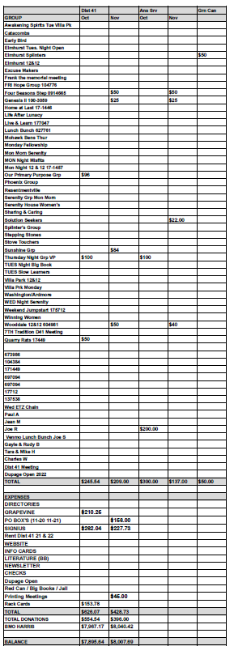
DCM: (Chris S.) Chris brought QR code meeting cards. 3,000 cards cost $130.
ALT. DCM: (Jeff A.) Absent.
ACCESSIBILITIES: (Open) Susan H. noted that the current issue of Concepts is available online at the Area website. Asked for individual articles to be submitted for Concepts.
ANSWERING SERVICE: (Maggie A.). Maggie A. stated that the Answering Service is dandy.
ALT. ANSWERING SERVICE: (Open)
ARCHIVES: (Lael L.) Lael L. inventoried approximately 200 tapes from the backroom at Anona East, and other sources. Motion was passed for Lael L. to create and have printed a pamphlet with AA speakers in it.
BTG: (Susan M.) No report.
CPC: (Open) (Jan S. Area 20) Inaudible.
ALT. CPC: (Open)
PI: (Open)
CORRECTIONS: (Brian L.) The National Conference on November 10-13, went off without a hitch. Thursday’s business included a bus ride to Joliet Prison. Over 300 people attended. Will submit request for registration and meal money ($158). Gave out pen pal information: (207) 671-2724 to reach Crystal or Allison from Area 19.
ALT. CORRECTIONS: (Lora B.) Lora B. will present more details from the Corrections Conference at a later time. Stressed that anonymity is maintained in all pen pal correspondence.

GRAPEVINE: (Joan N.) Grapevine is looking to collect audio stories of up to seven minutes in length. Topic is of your own choosing. If selected, it will be published on a YouTube playlist. Stories can be uploaded as MP3 files or dictated to the phone line.
ALT. GRAPEVINE: (Open)
LITERATURE: (Ed R.) Offered beginners kits. Will be resigning at the end of the year.
ALT. LITERATURE: (Open)
LCM: (Open)
NEWSLETTER: (Lael L.) Next Newsletter will be early 2023. Asked for articles.
TREATMENT: (Tom Ma.) No report.
ALT. TREATMENT: (Open)
WEBTECH: (Jeane M.) Reported 1,990 views for October. Posted in-person meeting list for Districts 41 and 42. Asked for event to be submitted. Will set up access to Concepts. Motion passed to donate $240 to the Meeting Guide and $120 per year thereafter.
WORKSHOPS: (Open)
OLD BUSINESS: Hard copy directories are being prepared for print for Districts 41, 42 and 43. Still waiting on District 40. Directories will have in-person only meetings that have been active for at least one year.
ONGOING BUSINESS: None.
NEW BUSINESS: The DuPage Open will be on February 18 at Parkview Community Church. District 41’s responsibility is the hospitality area. Leory L. and Brian L. volunteered to be representatives for District 41.
The Winter Assembly, hosted by District 11, will be on December 10 at 5211 Mill Valley Road in McHenry.
Closed with Responsibility Statement.

If you are a District 41 member and have not attended a district meeting within the last three months, chances are your name will be removed from the mailing list.

The next meeting will be the Open House with Area Delegate, Thursday, December 15, 2022 @ 7:00 P.M.

