MINUTES FOR DISTRICT 41 MEETING FEBRUARY 16, 2023 (HYBRID)
NOTE: Mailing Address - District 41 Treas. P.O. Box 7226, Villa Park, IL 60181
NOTE: District 41 web site: dupage41aa@gmail.com
NOTE: Mailing Address - District 41 Answering Service, P.O. Box 6365, Villa Park, IL 60181-5318
NOTE: NIA web site: www.aa-nia.org

PRESENT AT MEETING:
Maggie A., Lora B., Susan H., Chris J., Lee K., Lael L., Leroy L., Brian L., Jeane M., Susan M., Tom Mo., Joan N., Sarah O., Jim P., Ed R. and Chris S. and Lydia S.
Meeting opened at 7:00 p.m. with a Quiet Time, Serenity Prayer, GSR Preamble, 2nd Tradition and 2nd Concept for World Service.
Chris S. chaired the meeting.

INTRODUCTIONS:

New GSRs – None.

Guests – Michael K.

Anniversaries – None.

Birthdays – None.

Announcements – None.

Motion for Chris J. to become Literature Chair passed.

Susan M. stepped down as BTG Chair.

OLD BUSINESS:

ONGOING BUSINESS:

OFFICERS REPORTS:
SECRETARY: (Tom Mo.) Minutes from January were put into the record.
TREASURER: (Lydia S.) Went over Signius Answering Service bill, which included overage charges of $131.44. Lydia reviewed expenses and donations. Ending balance was $7,576. See below.
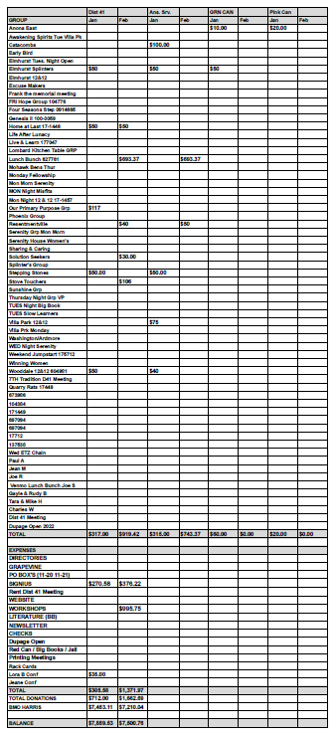

DCM: (Chris S.) No report.
ALT. DCM: (Jeff A.) Absent.
ACCESSIBILITIES: (Open)
ANSWERING SERVICE: (Maggie A.). Maggie stated that the Answering Service is busy. Asked for volunteers to take calls.
ALT. ANSWERING SERVICE: (Open)
ARCHIVES: (Lael L.) Lael completed digitizing old AA tapes.
Motion to make Jim P. the Alternate Webservant passed.
BTG: (Open)
CPC: (Open)
ALT. CPC: (Open)
PI: (Open)
CORRECTIONS: (Brian L.) Absent.
ALT. CORRECTIONS: (Lora B.) Reviewed local events. Gave out pen pal information. Reviewed Pink Can numbers.

GRAPEVINE: (Joan N.) No report.
ALT. GRAPEVINE: (Open)
LITERATURE: (Chris J.) No report.
ALT. LITERATURE: (Open)
LCM: (Open)
NEWSLETTER: (Sue H.) No report.
TREATMENT: (Tom Ma.) Good Sam Hospital needs volunteers for Detox, especially females. Also the Friday night meeting there at 7 pm needs chair people. I am going next Friday and will provide more details after that.
Maggie A. asked for support for Serenity House Friday night meeting.
ALT. TREATMENT: (Open)
WEBSERVANT: (Jeane M.) Reported 2,136 views in January. Worked with Jim P. on Meeting Guide. Asked for events to post.
WORKSHOPS: (Lee K.) Fourth Step Workshop will be March 25th at Anona East from 12:00 noon to 3:00 p.m. Flyer to come.
Motion passed to table discussion of treatment center and sober living outreach opportunities.
Maggie A. requested $200 for food, cups, plates and napkins. Motion to donate $200 passed.
Closed with Responsibility Statement.

If you are a District 41 member and have not attended a district meeting within the last three months, chances are your name will be removed from the mailing list.

The next meeting will be held Thursday, March 16, 2023 @ 7:00 P.M.

