MINUTES FOR DISTRICT 41 MEETING MARCH 16, 2023 (HYBRID)
NOTE: Mailing Address - District 41 Treas. P.O. Box 7226, Villa Park, IL 60181
NOTE: District 41 web site: dupage41aa@gmail.com
NOTE: Mailing Address - District 41 Answering Service, P.O. Box 6365, Villa Park, IL 60181-5318
NOTE: NIA web site: www.aa-nia.org

PRESENT AT MEETING:
Lora B., Chris J., Lee K., Lael L., Leroy L., Brian L., Jeane M., Tom Mo., Joan N., Jim P., Ed R., Chris S. and Lydia S.
Meeting opened at 7:00 p.m. with a Quiet Time, Serenity Prayer, GSR Preamble, 3rd Tradition and 3rd Concept for World Service.
Chris S. chaired the meeting.

New GSRs – None.

Anniversaries – Lee K. (43 yrs.), Joan N. (17 yrs.)

Birthdays – Leroy L.
Treasurer’s Report below.
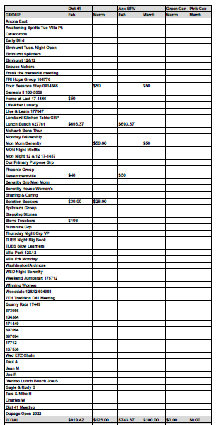
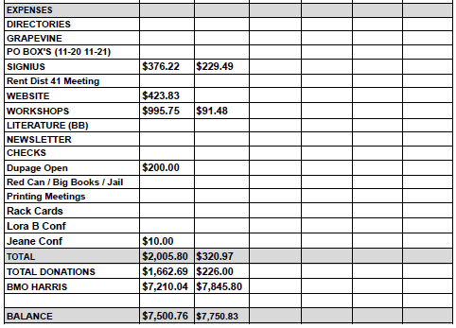
This month’s meeting consisted of in-depth discussions of four topics that will be considered at the General Service Conference:
- A Motion to recommend publication of a simplified version of the first 162 pages of Alcoholics Anonymous (separate from the original) passed.
- A Motion to recommend augmentation of youth pamphlets with separate video presentations, also passed.
- A non-voting discussion of AA’s role on Instagram and the protection of anonymity thereon.
- A non-voting discussion of safety concerns at AA meetings and the measures that can be taken to ensure the safety of our members.

Closed with Responsibility Statement.

If you are a District 41 member and have not attended a district meeting within the last three months, chances are your name will be removed from the mailing list.

The next meeting will be held Thursday, April 20, 2023 @ 7:00 P.M.

