MINUTES FOR DISTRICT 41 MEETING MAY 18, 2023 (HYBRID)
NOTE: Mailing Address - District 41 Treas. P.O. Box 7226, Villa Park, IL 60181
NOTE: District 41 web site: dupage41aa@gmail.com
NOTE: Mailing Address - District 41 Answering Service, P.O. Box 6365, Villa Park, IL 60181-5318
NOTE: NIA web site: www.aa-nia.org

PRESENT AT MEETING:
Lora B., Chris J., Lael L., Tom Mo., Jim P., Chris S. and Lydia S.
Meeting opened at 7:00 p.m. with a Quiet Time, Serenity Prayer, GSR Preamble, 5th Tradition and 5th Concept for World Service.
Chris S. chaired the meeting.

INTRODUCTIONS:

New GSRs – None.

Guests – None.

Anniversaries – None.

Birthdays – None.

Announcements – None.

GSR-CC & Q: GSRs reported on their meetings.

OFFICERS REPORTS:
SECRETARY: (Tom Mo.) Minutes from April were put into the record.
TREASURER: (Lydia S.) Lydia S. reviewed donations and expenses. Ending balance is $7,625.92. See report below.
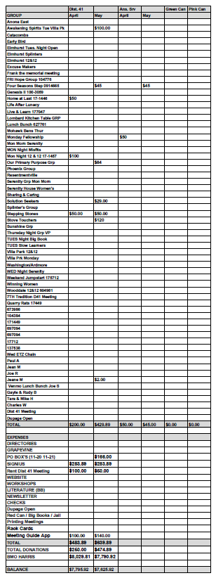
Jean M. put Venmo on the D-41 website to facilitate contributions. Post Office box rates have been raised for the coming year. Lydia S. stepped down as Treasurer.
DCM: (Chris S.) Chris S. will ask Chris D. (Area 20 Delegate) to come back to provide further information on the General Service Conference.
ALT. DCM: (Open)
ACCESSIBILITIES: (Open)
ANSWERING SERVICE: (Maggie A.). Absent.
ALT. ANSWERING SERVICE: (Open)
ARCHIVES: (Lael L.) Continuing to digitize tapes from Anona East.
BTG: (Open)
CPC: (Open)
ALT. CPC: (Open)
PI: (Open)
CORRECTIONS: (Brian L.) Absent.
ALT. CORRECTIONS: (Lora B.) A discussion of orientation in the Jail ensued.

GRAPEVINE: (Joan N.) Absent.
ALT. GRAPEVINE: (Open)
LITERATURE: (Chris J.) Sold five beginner’s kits. Received GSR kit from New York. However, GSO will only have kits online from now on.
ALT. LITERATURE: (Open)
LCM: (Open)
NEWSLETTER: (Sue H.) Absent. Lora B. stated the next issue will be in June.
TREATMENT: (Tom Ma.) Absent.
ALT. TREATMENT: (Open)
WEBSERVANT: (Jeane M.) Absent.
ALT. WEBSERVANT: (Jim P.) Jim P. reported 1,719 hits in April. Jim P. discussed coordination of meeting listings between CASO and Meeting Guide. Lora B. will procure a list of registered groups from the Area Registrar.
WORKSHOPS: (Lee K.) Absent.

OLD BUSINESS: None.

ONGOING BUSINESS: Lora B. stated that Serenity House is looking for women sponsors and help with the Friday night 7:00 p.m. meeting. Will put together a notice for the D-41 website.

NEW BUSINESS: Discussed a semi-annual contribution of $300 to be split between the Area and GSO.
Discussed having a District picnic. Motion passed to have a speaker meeting outside. Lora B. will check on the York Woods location.

Closed with Responsibility Statement.

If you are a District 41 member and have not attended a district meeting within the last three months, chances are your name will be removed from the mailing list.

The next meeting will be held Thursday, June 15, 2023 @ 7:00 P.M.

