MINUTES FOR DISTRICT 41 MEETING OCTOBER 19, 2023 (HYBRID)
NOTE: Mailing Address - District 41 Treas. P.O. Box 7226, Villa Park, IL 60181
NOTE: District 41 web site: dupage41aa@gmail.com
NOTE: Mailing Address - District 41 Answering Service, P.O. Box 6365, Villa Park, IL 60181-5318
NOTE: NIA web site: www.aa-nia.org

PRESENT AT MEETING:
Maggie A., Lora B., Rick B., Chris J., Lee K., Lael L., Leroy L, Dennis L., Tom M., Joan N., Jim P., Ed R., Chris S. and Gerry W.
Meeting opened at 7:00 p.m. with a Quiet Time, Serenity Prayer, GSR Preamble, 10th Tradition and 10th Concept for World Service.
Chris S. chaired the meeting.

INTRODUCTIONS:

New GSRs – Jim P. (Gatehouse Group)

Guests – Rick F.

Anniversaries – Leroy L. (32 yrs.)

Birthdays – None.

Announcements – Dennis L. (D-42 Corrections Chair), announced that an orientation will take place at the DuPage County Jail, this Wednesday, October 25, 2023, at 6:00 p.m. Dennis explained the particulars for qualifying for the orientation through J.U.S.T.
Motion passed to pay Lee K. in full for the internet hotspot and service through March of 2025.

Maggie A. gave preliminary information on the DuPage Open occurring in February 2024. District 41’s role will entail the following:
1. Procuring a speaker with 20 years or more of continuous sobriety

2. Promoting the event

3. Naming a Chair. Lora B. volunteered for the Chair position. Chris S.
will assist

GSR-CC & Q: GSRs reported on their meetings.

OFFICERS REPORTS:
SECRETARY: (Tom Mo.) Minutes from September were put into the record.
TREASURER: (Gerry W.) Gerry reviewed donations and expenses.
See report below.
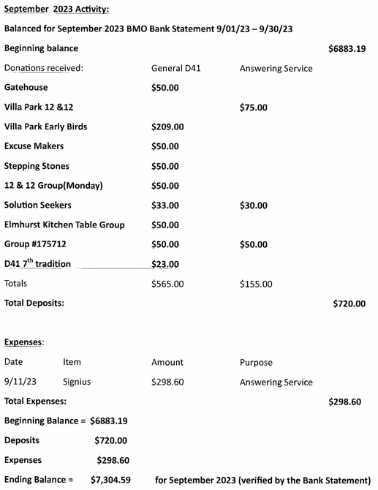 | 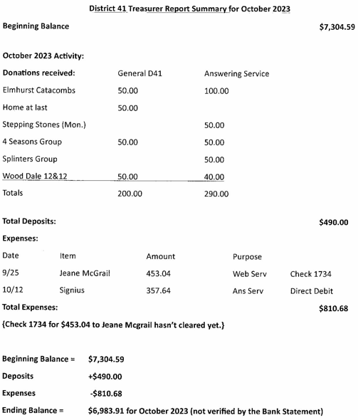

DCM: (Chris S.) Nothing further.
ALT. DCM: (Open)
ACCESSIBILITIES: (Open)
ANSWERING SERVICE: (Maggie A.). Oct 19th Answering Service Report
We have a had a steady stream of about 3-5 calls a week. Volunteers are doing a great job. Having the Meeting Guide app and the District Website to refer people to is amazingly valuable.
I have contributions from the Early Birds of $151 dollars to send in. I will encourage the Early Birds to connect with Geri so there is less of a gap between donating and deposit. (This current money was in the Anona Office for a while before I heard of it)
Thanks for letting me be of service.
Maggie
ALT. ANSWERING SERVICE: (Open)
ARCHIVES: (Lael L.) No report. Will purchase Chicago History from CASO.
BTG: (Open)
CPC: (Open)
ALT. CPC: (Open)
PI: (Open)
CORRECTIONS: (Brian L.) Absent.
ALT. CORRECTIONS: (Lora B.) Reported approximately $1,000 in contributions from District 41 directly to Area 20. Approximately $5,000 in the Pink Can fund.
Dennis L. reviewed Pink Can numbers for DuPage County, which has contributed 72% of all Pink Can funds in Illinois.

GRAPEVINE: (Joan N.) No Report. Recommended Grapevine app.
ALT. GRAPEVINE: (Open)
LITERATURE: (Chris J.) Chris J. passed around guidelines for stories to be submitted for the “Do You Think You’re Different?” pamphlet. Also gave out flyers for AAWS Fall Flash Clearance sale.
ALT. LITERATURE: (Open)
LCM: (Open)
NEWSLETTER: (Susan H.) Absent.
TREATMENT: (Tom Ma.) Absent.
ALT. TREATMENT: (Open)
WEBSERVANT: (Jeane M.) Absent. See report.
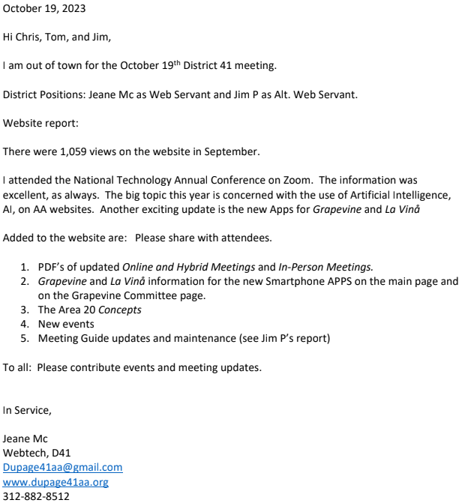
ALT. WEBSERVANT: (Jim P.) Reviewed the work of the past two months. Stated that there are 195 meetings, of which 115 are in District 41, and 80 in District 42. Ninety-three District 41 meetings had changes to be made.
WORKSHOPS: (Lee K.) No report.

OLD BUSINESS: Maggie A. reported that the hard copy meeting directories are ready to go to the printer. Motion passed to purchase 2,750 copies of the meeting directories at $.34 each.

Closed with Responsibility Statement.

If you are a District 41 member and have not attended a district meeting within the last three months, chances are your name will be removed from the mailing list.

The next meeting will be held Thursday, November 16, 2023 @ 7:00 P.M.

